Scene Walkthrough Project: Technical Document

- Scene overview-
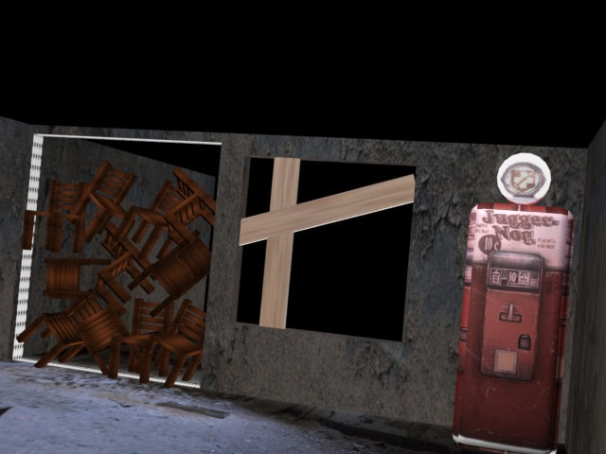

Overall view of the scene. Includes the three objects and their surroundings.

- Jugger-nog-
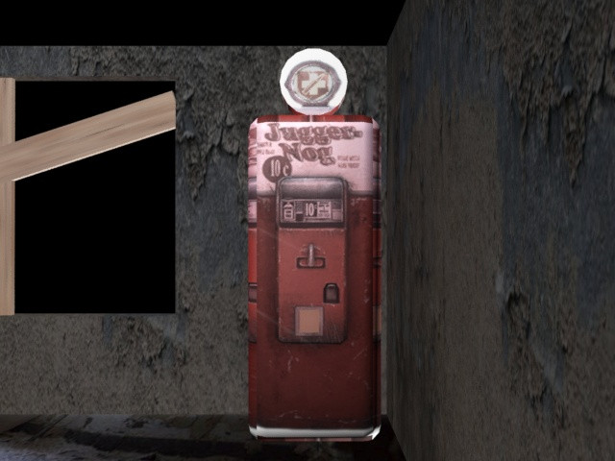
Jugger-nog is a perk machine from Call of Duty: Zombies. To make it, I used a Chamfer Box, a cylinder, and a texture.

- Window barriers-
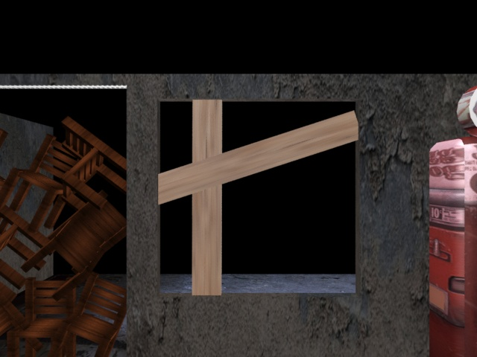

This is a window with boards. I used a rectangle for the wall and frame of the window. I then used Boolean to take out what is the frame inside the rectangle. I then used another rectangle and applied a wood texture to the rectangle to represent boards. In the animation, more barriers come and build themselves into the wall one by one.

- Chair barrier-
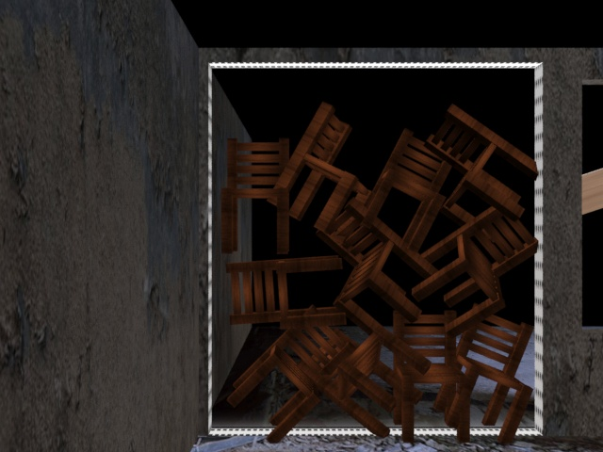

For this, I used Boolean to remove the “door way.” I then made a single chair and made instances of the chair. I then rotated and transformed the chairs to stack up and form a barrier in the door way. In the animation, the chairs float up and disappear into the sky.

